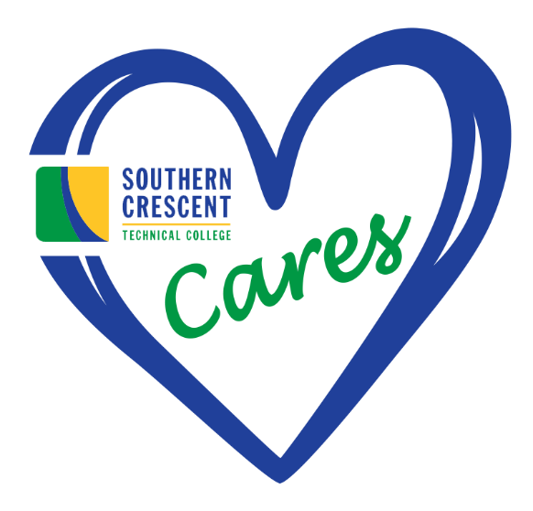
Attention SCTC Students: CARES Funding is running out!

The college will not award an automatic one-time disbursement as done in the past. Students will be required to request CARES emergency funds beginning Summer 2022!

How to Receive CARES for Summer 2022
To apply for CARES emergency funding, students will be required to complete a CARES emergency application:
- CARES Emergency awards will be granted for a maximum of $1000.00.
- Students can only apply once per term.

CARES Emergency Applications
- Priority will be given to students eligible for federal Pell based on FAFSA data.
- Students can also apply for CARES emergency funds once a semester
- CARES Act funds will be paid to eligible applicants until funds are exhausted
- The award is not a loan and does not have to be paid back
- Funds not spent in one term will be moved to the upcoming semester

How CARES funds are received:

How will I receive my CARES Funds?
BankMobile is the official Southern Crescent Technical College Refund Disbursement Processor. Students are expected to activate the BankMobile "refund selection" to choose how they wish to receive refund disbursements from Southern Crescent Technical College. There are multiple options provided for choosing how to receive refunds. Students can choose to have funds transferred to an existing bank account, receive a paper check or choose to receive your funds electronically by direct deposit into your BankMobile account, in which you will receive a BankMobile card for purchases. All refunds are processed through the BankMobile Disbursement Process.

To learn more about the Southern Crescent Technical College partnership with Bank Mobile, you can view our contract here.

NOTE: The college will not award an automatic one-time disbursement as done in the past. Students will be required to request emergency funds!

Visit the SCTC Cares Reporting for more detail information.

CARES Administrator: Dr. Michelle Bedford

